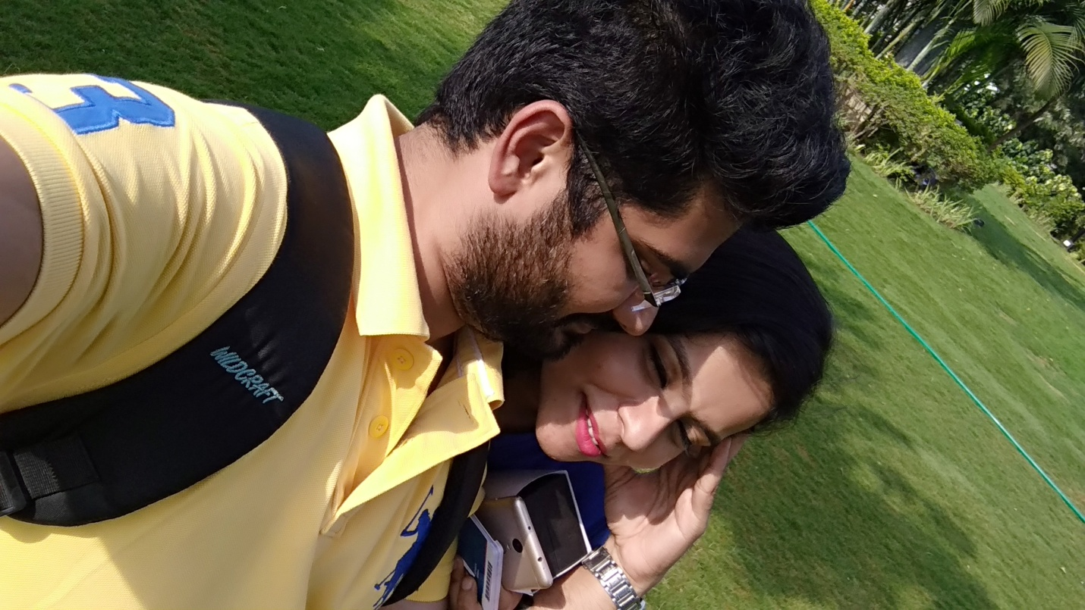

I see the world in you <3

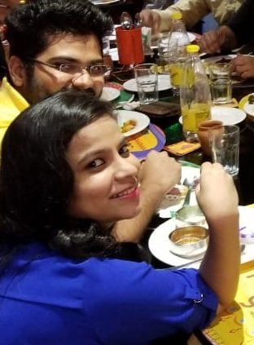

In this pic I am at your back, promise I will always have your back ☺

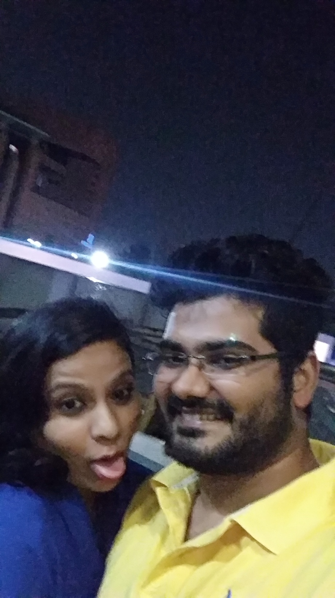

I Love the way you are...

Always be as you are... :\*

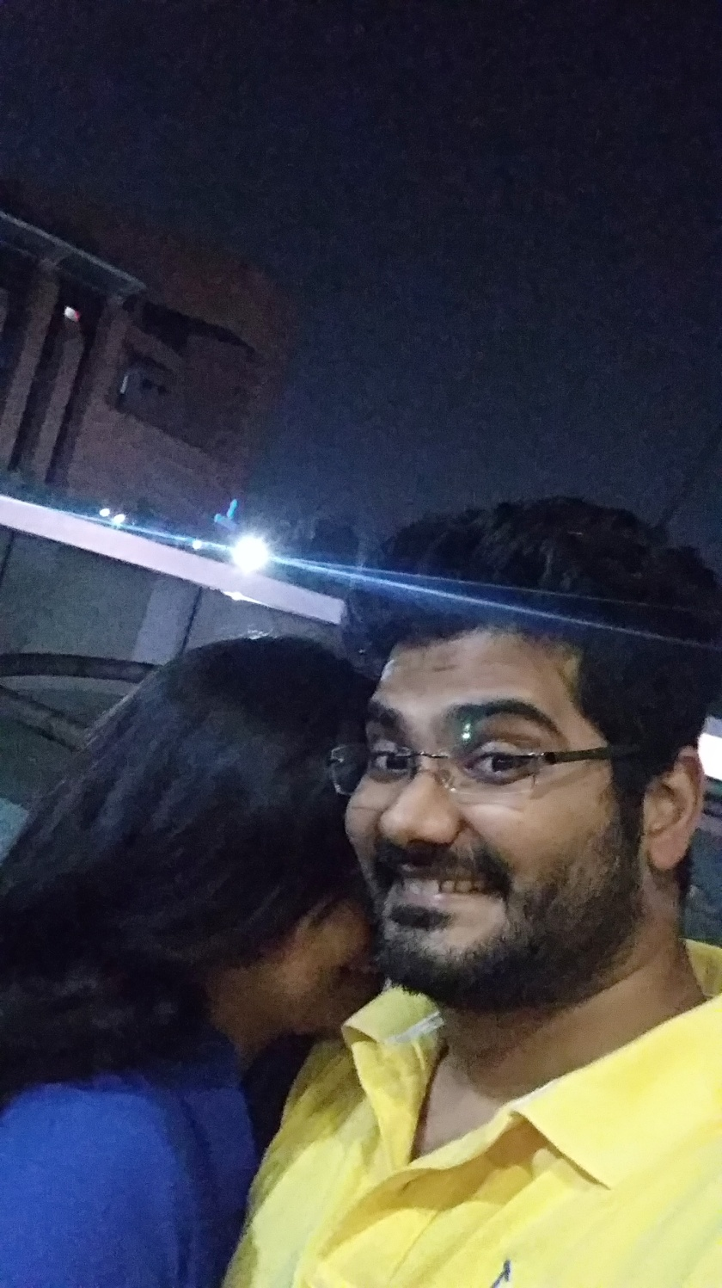

You are the reason for my widest smile...

Coz you are my sunshine <3 <3 <3

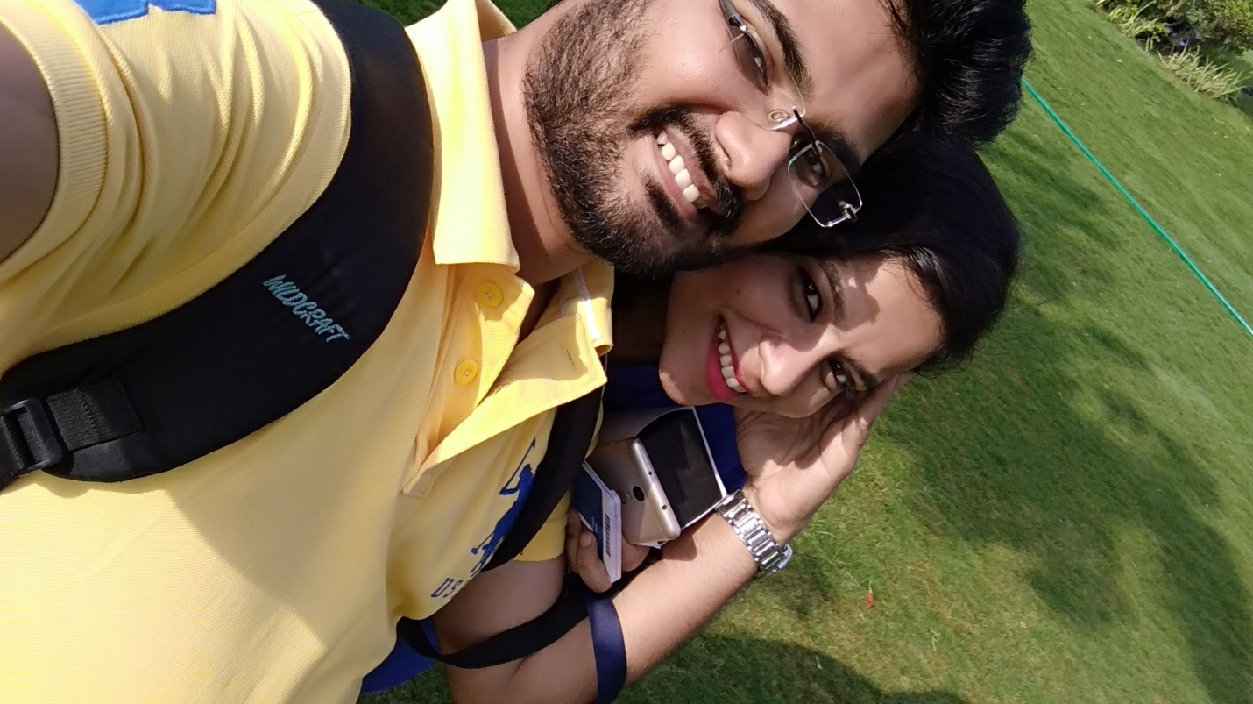

I'll be your soldier,

For you I will lift any boulder...

Together we will grow older...

Everyday we will come closer...

I LOVE U :\* :\* :\*